## Properties of the Road Tool - Road

The Road section of the road’s properties allows you to adjust the color, the road geometry (Spline, Line or Bezier) and auto merge preferences.

**To change the color of the road in the properties palette:**

* Select the road on your plan
* Select the **Road** section on the properties palette
* Select the **Color** bar (the blue bar the image below)
* Some color options will become available for you to choose from
* 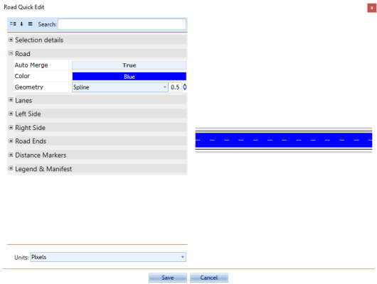
* Road_Properties

The **auto merge** feature controls whether a new road will automatically merge with the selected road. As shown below, when set to **True** it means the new road will automatically merge, **False** means it will not.

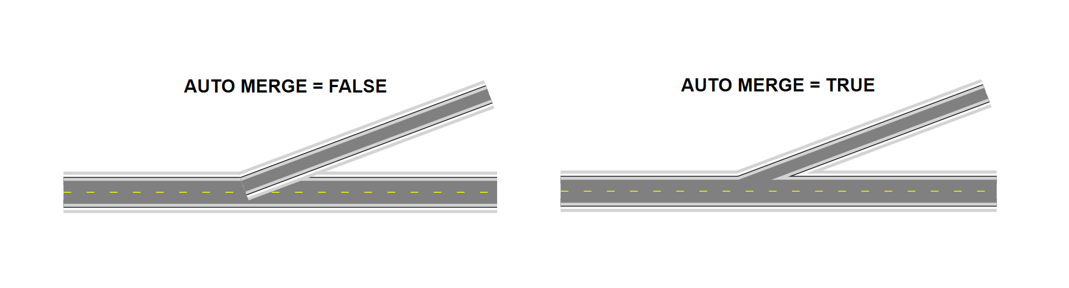

Road_Auto_Merge_ON-OFF